**Evolution Of React**

React is a JavaScript library used to build the user interface for web applications. React was initially developed and maintained by the folks at Facebook, which was later used in their products (WhatsApp & Instagram). Now it is an open source project with an active developer community. Popular websites like Netflix, Airbnb, Yahoo!Mail, KhanAcademy, Dropbox and many more use React to build their UI. Modern websites are built using MVC (model view controller) architecture. React is the ‘V’ in the MVC which stands for view, whereas the architecture is provided by **Redux** or **Flux**. React native is used to develop mobile apps, the Facebook mobile app is built using React native.

Facebook’s annual F8 Developer conference 2017, saw two promising announcements: **React Fiber** and **ReactVR**. React Fiber is a complete rewrite of the previous release focusing on incremental rendering and quick responsiveness, React Fiber is backward compatible with all previous versions. ReactVR is built on top of React Native frameworks, it enables developing UI with the addition of 3D models to replicate 360-degree environment resulting in fully immersive VR content.

**Why Learn React?**

***“Let’s just write less and do more!!”***

React is among the easiest JS libraries you can start with. Conventional Vanilla JavaScript is more time-consuming, why waste time writing lengthy code when u can get things done smoothly with React. React has over 71,200 stars on [GitHub](http://github-rank.com/star?language=All), making it the 4thmost starred project of all time. After looking at the below example, I am sure you would understand why front-end developers across the world are switching to React. Now let’s try coding a set of nested lists in React and compare it with conventional JavaScript syntax.

*Example:****30****lines of code in Vanilla JavaScript can be replaced by just****10****lines of React code, isn’t that awesome!!*

**React**

|  |  |
| --- | --- |
| 1  2  3  4  5  6  7  8  9  10  11  12  13  14  15  16  17  18  19  20  21  22 | <ol>    <li>List item 1 </li>      <li>List item 2 (child list)    <ul>    <li>Subitem 1</li>      <li>Subitem 2</li>    </ul>    </li>      <li>Final list item</li>    </ol> |

**Equivalent Vanilla** **JavaScript**

|  |  |
| --- | --- |
| 1  2  3  4  5  6  7  8  9  10  11  12  13  14  15  16  17  18  19  20  21  22  23  24  25  26  27  28  29  30  31  32  33 | React.createElement(   "ol",   null,   React.createElement(   "li",   null,   "List item 1 "   ),   React.createElement(   "li",   null,   "List item 2 (child list)",   React.createElement(   "ul",   null,   React.createElement(   "li",   null,   "Subitem 1"   ),   React.createElement(   "li",   null,   "Subitem 2"   )   )   ),   React.createElement(   "li",   null,   "Final list item"   )  ); |

As you have already figured it out when the complexity increases, the JavaScript code generated becomes unmanageable. This is where JSX comes to the rescue ensuring the code is short and easily readable.

**ReactJS Tutorial- Key Terminology**

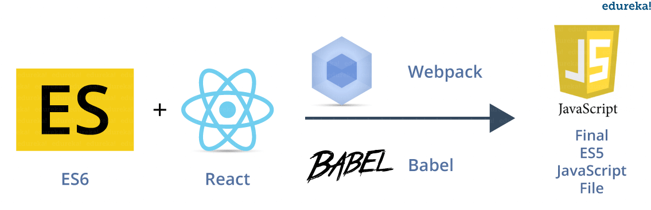

**Figure:** *ReactJS Tutorial – Dependencies*

Before we dive deeper into this ReactJS tutorial, let me first introduce you to some key terms you need to be familiar with.

**JSX (JavaScript Extension)**

JSX Allows us to include ‘HTML’ in the same file along with ‘JavaScript’ (HTML+JS=JSX). Each component in React generates some HTML which is rendered by the DOM.

**ES6 (ES2015)**

The sixth version of JavaScript is standardized by [ECMA](https://en.wikipedia.org/wiki/ECMAScript) International in 2015. Hence the language is referred to as ECMAScript. ES6 is not completely supported by all modern browsers.

**ES5(ES2009)**

This is the fifth JavaScript version and is widely accepted by all modern browsers, it is based on the 2009 ECMA specification standard. Tools are used to convert ES6 to ES5 during runtime.

**Webpack**

A module bundler which generates a build file joining all the dependencies.

**Babel**

This is the tool used to convert ES6 to ES5. This is done because not all web browsers can render React (ES6+JSX) directly.

**React Features Overview**

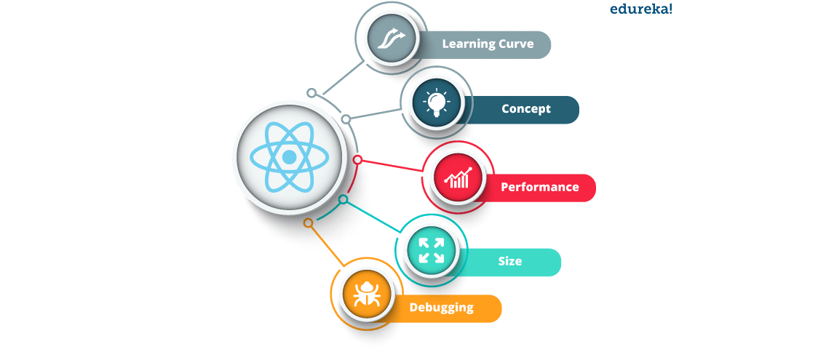**Figure*:****ReactJS Tutorial – React Features*

**Learning Curve**

React has a shallow learning curve and it is suitable for beginners. ES6 syntax is easier to manage especially for smaller to-do apps. In React, you code in the ‘JavaScript’ way, giving you the freedom to choose your tool depending upon your need. Angular expects you to learn one additional tool ‘typescript’ which can be viewed as the ‘Angular’ way of doing things. In ‘Angular’ you need to learn the entire framework even if you’re just building a simple UI application.